1：

Mr Schultz, I did not interrupt you. I would ask you at least to be polite. Clearly, politeness was not part of your education. Please would you refrain from interrupting and learn some manners above all. Why are you getting so het up Madam President, rather than concerning himself with the internal affairs of the European Peoples Party, Mr Schultz would do well to concentrate on those of his own group, which has a minority in Parliament and lost the elections in Italy. Clearly, this irritable behaviour is the evidence of the political difficulties currently being experienced by his group.

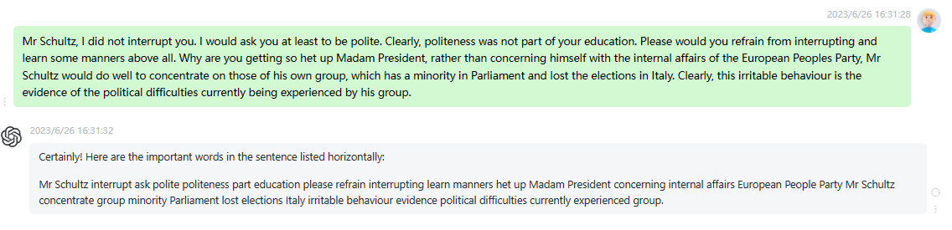

时延0.2s

2:

Madam President, the Italian Prime Minister has made a very practical proposal, and I would like the European Parliament to express its opinion on this matter. As I said before, the hundreds of Members of the European Parliament from the European Peoples Party who were present at Rome can testify to this. The proposal is for an incisive European Union economic intervention to support the Palestinian people, so that the economic growth of the Palestinian people can contribute to reducing existing political tension. This is a subject for debate, a practical proposal made by the Italian Prime Minister to protect

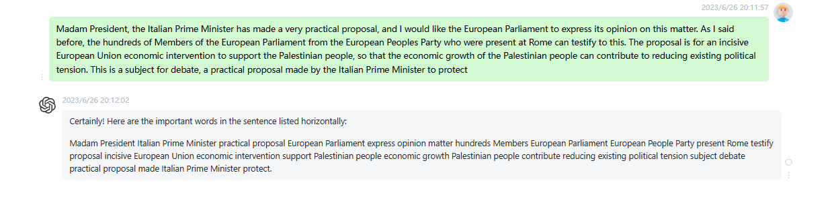

时延0.25s

3:

I had invited him because he embodied the hopes of the overwhelming majority of people in Afghanistan for a future of peace and freedom. He had warned us against the Taliban regimes tacit support for international terrorism and he did everything in his power to fight against those who misused Islam in order to flout the most basic human rights. He sent a strong message to us to help him to establish peace as soon as possible. I regret that the West did not heed this message and did not do more to help this brave man. Many of you

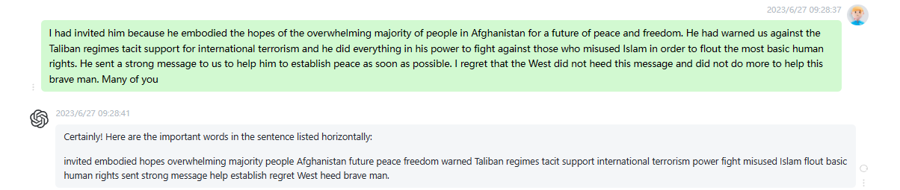

时延0.2s

4:

As you know, the dreadful terrorist attacks in the United States have fuelled quite legitimate feelings of concern within the European Parliament itself. The Sunday Telegraph even reported that we were the target of very serious threats, which had been thwarted. I would like to confirm that the European Parliament has never known of any threats. On Monday, the prefect of the Bas Rhin department called me personally in order to tell me that he formally denied that these threats had been made. As you know, the French authorities also formally denied the threats, as confirmed in an official press

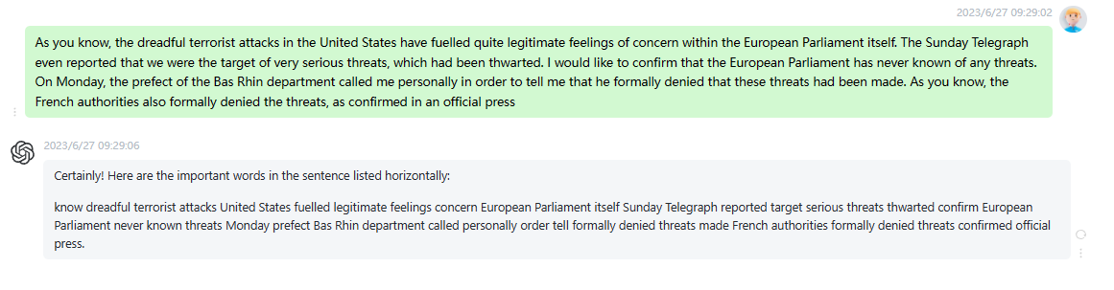

时延0.2s

5:

I can assure you, however, that the staff of the Bureau are constantly monitoring the issue of security of the European Parliament, the vice presidents, the Quaestors, the President and General Secretariat. We took a number of measures to increase security, particularly in December 2000, at Christmas, when there were rumours circulating that Strasbourg cathedral was a target. Given that the cathedral is close by, a series of measures was of course taken at that time. Immediately after the events of 11 September, the Secretary General and I were in contact, and we have introduced additional measures to further increase

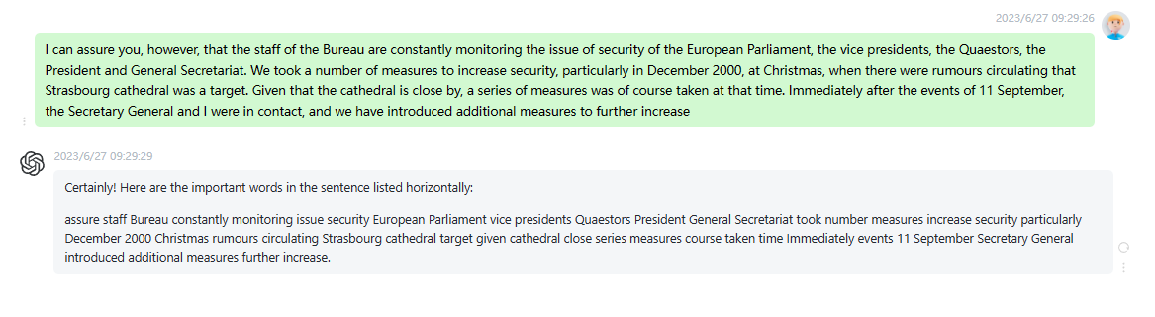

时延0.15s

6:

The UEMOA, whose structure is closely modelled on that of the European Union, plays a key role in the organisation of regional cooperation in West Africa. This is why we hope to build further on the links that already exist between this organisation and the European Union. This is the aim of Mr Toures visit, and I would like to extend a very warm welcome to him. The next item is the Council and Commission statements with a view to the informal and extraordinary meeting of the European Council on Friday 21 September, on the measures needed to tackle terrorism.

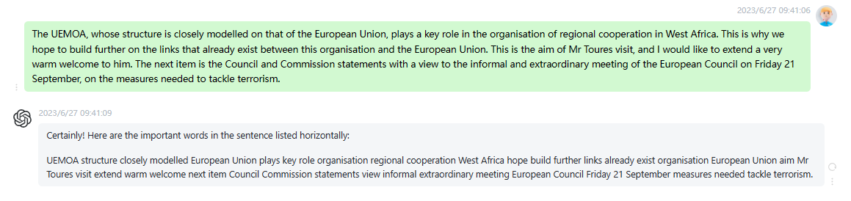

时延0.15s

7:

The Presidency and the Council immediately condemned, in the strongest possible terms, the perpetrators, organisers and sponsors of these barbaric acts. The strikes against the American nation are a direct attack on the values of democracy, tolerance, respect for human rights and the rule of law that are shared by America and Europe, and upon which our societies and others elsewhere in the world, are based. At its emergency session on Wednesday 12 September, the Council of Foreign Affairs Ministers expressed its profound solidarity with the American people. We clearly stated that no effort would be spared to identify, bring

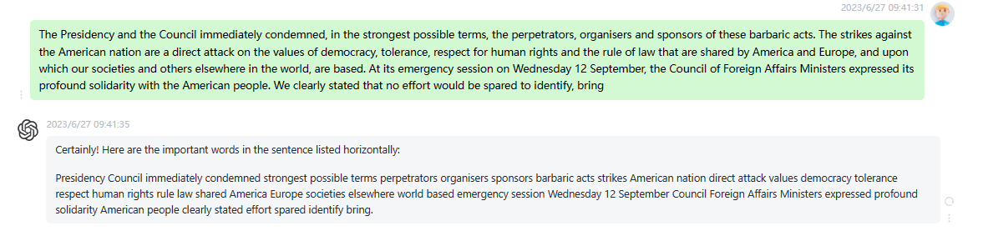

时延0.2s

8:

Madam President, at the instigation of the General Affairs Council, the Council of Transport Ministers held a meeting on 14 September. The Council reviewed the urgent measures taken by each Member State in order to guarantee the safety of air travel. It also set up a special working group, comprising representatives of the Member States and of the European Commission, which is responsible for increasing cooperation and coordination among the Member States to ensure the uniform and effective application of security measures, including by legislative means. A preliminary report on this subject is to be laid before the Council of

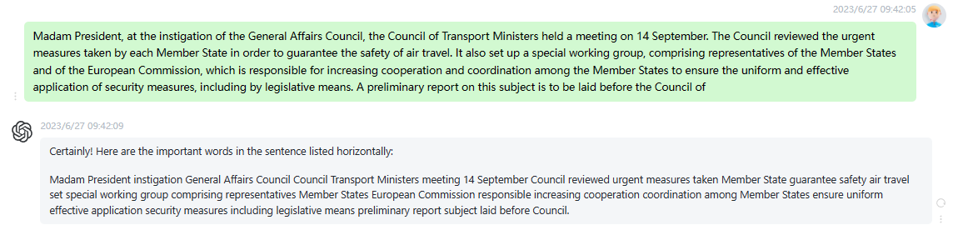

时延0.2s

9

The second proposal concerns the introduction of a European warrant of arrest. The Council will consider instruments employed in the investigation of criminal acts and will ensure that a suitable balance is struck between the protection of privacy and the needs of the investigative authorities. Finally, the Justice and Home Affairs Ministers will examine a number of measures aimed at strengthening transatlantic judicial cooperation in the areas of policing, intelligence and immigration. Madam President, Commissioner, ladies and gentlemen, the fight against terrorism requires the use of all kinds of instruments to monitor financial flows, to identify suspects, to make air

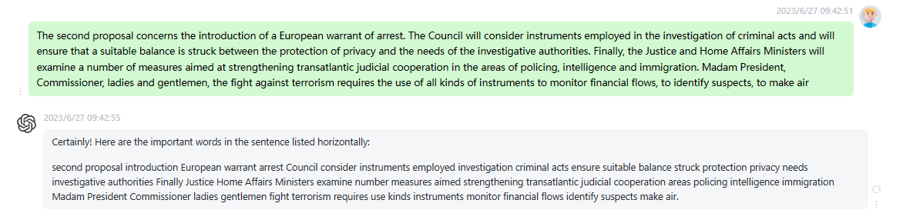

时延0.2s

10:

The EU will be much more effective if it can further develop its Common, Foreign and Security Policy and can activate its Common European Security Policy at the earliest opportunity. The Common, Foreign and Security Policy will have to be used preventatively, rather than as a means of reprisal. If the battle against terrorism is to be truly effective, we will also need to strengthen our policies with regard to the countries and the regions of the world that appear to nurture terrorism. We will have to enhance and deepen our political dialogue and use every possible means at our

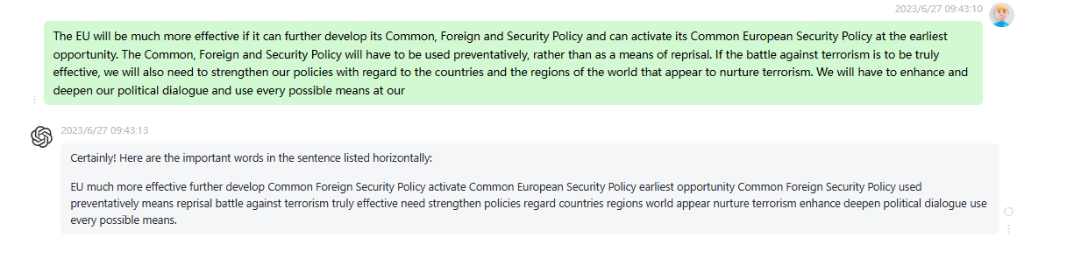

时延0.15s